L U M S D E N S C H O O L
Newsletter Issue 21 – July 29th 2016

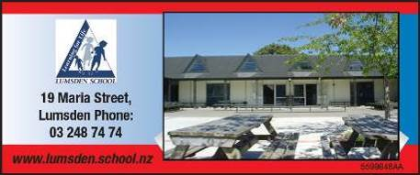

Contents
Page 1
- Principal’s Letter

Page 2
- Looking Ahead 2016
- Additional Students Travelling on Dome Network Buses
- Welcome to School
- Change of Clothes Reminder

Page 3
- Financial Contribution
- Positive Playground
- Master Cookie Maker
- Skipping Class!
- Happy as Sandboys (and girls)

Page 4
- Soccer Results
- Netball Results
- Rugby Results
- Entertainment Books Available Now
- Firewood for Sale
- Makarewa School Pool Learn to Swim Lessons

Page 5
- Our Playground
- Dipton Playgroup Mid-Winter Shopping Night

Attached:
- Books for Sale only 50¢
- Well Child Service Newsletter

NEWSLETTERS

Please

- Look for it on a Friday afternoon

- Take note of anything needing attention

- Return slips as soon as possible

Dear School Friends and Families

I can’t recall another year with so much ‘Sprinter’
weather….The rhodies think it’s Spring while it’s still Winter.
Hope it stays favourable for all of you getting into calving.

It’s been a good week back, and we’re pleased to welcome Harri (Year 6) and Tyrese (Year 2). The children are engaging really well in their House Group afternoon Arts rotations - Drama/Music/Art/Dance. There will have been some presentations at assembly this week to showcase some of this learning. This is a good lead-up to Production work too, and it’s great to see so many of the Room 2 and 3 children keen to audition for speaking parts and solo singing parts next week. These children will have brought home audition script sheets to practice from.

You may have spotted the new sign on the outside wall at the
end of Room 4, expertly made by Canvart P.T.O.). This is part of
the launch of our new Positive Playground system which is
designed to promote respectfulness, responsibility, and safety in the playground. Sonya Hoffman has sewn pockets into our new teacher Lumsden School vests, which teachers fill with ‘Gotcha’ tokens, ready to give out to children in the playground showing excellent examples the playground values and practices which we’re promoting.

Next Friday we welcome the Great Southern Dash crew
members to school – About 70 people in crews of about 3 (24
cars). Basically it’s a like the ‘Variety Bash’ which you may
have heard of, which is a children’s charity fundraiser, except in the ‘Dash’ they’re not fundraising but ‘Giving back’. Our children will be in groups, adopting a crew when they arrive. They’ll have lunch with us, followed by some games before they hit the road again. You’re welcome to join us.

Looking forward to Polyfest on Monday August 29th (Week 6), when the whole school will perform again this year at Stadium Southland. No doubt the children’s kapa haka items will be well polished by then with Miss Madden’s expert guidance.

Next Thursday afternoon we hold our annual school speeches
finals – Well done to Troy, Caleb H, Charlotte, Kynan, Fynn,
Rachael, Mackenzie and Luke who have qualified for this stage,
and we hope many of you will be able to join us as we are
informed and entertained by these Year 5 and 6 speakers. Visitors are welcome to stay for a cuppa following the speeches. The first two place-getters will be going through to the Mid Dome stage to be held at Mossburn.

Do pop in at any stage over the next couple of weeks to take advantage of our 50¢ book sale. We have needed to make way for new books in the library, and Miss Bray has done a great job weeding out old books. It’d be great if lots of them could find new homes with our school families.

Have a good weekend. May it be more Sprinter than Winter! Ka kite ano,

Andrew Watson
Principal

Thur




Reminder: text follow lumsdenschool to 8987 so that you will receive immediate text notification of alerts and reminders via our twitter account (e.g. snow days, cancellations).




Looking Ahead 2016
Monday | Tuesday | Wednesday | Thursday | Friday | Saturday | Sunday
1 Aug | 2 | 3 | 4 Speeches 1.30 pm – Senior Classes | 5 Variety Dash here 10.50 – 12.30 | 6 | 7
8 | 9 BOT Meeting; Eileen Ryan PHN here | 10 | 11 | 12 | 13 | 14
15 | 16 | 17 Northern Speeches, Mossburn | 18 | 19 | 20 | 21
22 | 23 Eileen Ryan PHN here | 24 | 25 | 26 | 27 | 28
29 Polyfest, Invercargill | 30 | 31 | 1 Sept | 2 | 3 | 4
5 | 6 St John in Schools | 7 | 8 | 9 | 10 | 11
12 | 13 BOT Meeting; Eileen Ryan PHN here | 14 | 15 | 16 | 17 | 18
19 School Photos | 20 | 21 | 22 Production | 23 End of Term 3 | 24 | 25

Additional Students Travelling on Dome Network Buses
From time to time parents may wish for additional students to accompany their children home on a school bus. There may also be times when a parent wants a student to travel on a different bus to their normal one for a special event such as sports practice.

The Dome Network is happy to support this practice but it must take place in a safe and organised manner. If you want additional students to come home with your children the onus is on you to make contact with the bus driver to ensure that there is sufficient space on the bus. If the driver is satisfied that they will not have an over-loading problem they will agree to transporting the additional passengers. At this time the parent making the request is required to supply the names of the additional passengers to the bus driver, and contact their school to let them know.

Please be advised that additional passengers on bus services are required to meet the high expectations of good behaviour. Any students found to misbehaving or otherwise inconveniencing existing students will be prevented from travelling again in the future.

Welcome to School
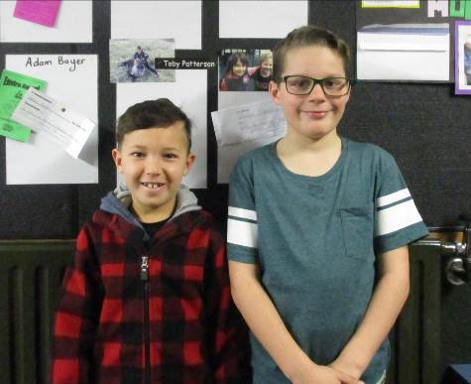

This week we are pleased to welcome Tyrese Gemmell and Harri Wilson to Lumsden School. Tyrese has joined Room 5 and Harri is in Room 3.

Change of Clothes Reminder
Due to the muddy grounds please send a spare change of clothes with all children. Thanks.

Financial Contribution
Financial donations for the third term are now due. The BOT ask for donations from each family to the value of $100 per child for the first two children and $70 for the third per annum. We ask that you pay $25 per child (for the first two) and $17.50 for the third child for the third term as soon as possible. Alternatively you may wish to pay the full annual donation as a lump sum. Please make payment to Sharon in the office at school or directly into the school bank account 030960-0112624-00 (child/ren’s name as reference). Thank you to those families who have already paid.
Please feel free to discuss this with Andrew if you have any other questions or concerns about this request.

Positive Playground
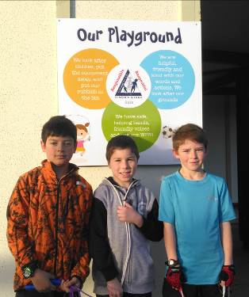

Boston, Mitch, and Cooper in front of our new Positive Playground sign which reminds the children about how to keep our playground a fun, friendly and safe place.

Master Cookie Maker


Ruby made some delicious biscuits as a maths activity this week.

Skipping Class!
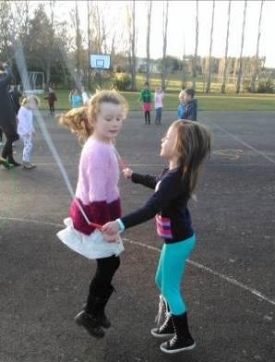

Jodi and Zoe show how partner skipping is done during our Fitness skipping rotation this week.

Happy as Sandboys (and girls)
Children enjoying the new sand in the old Sandpit. Many thanks to South Roads for supplying and delivering this in the holidays.
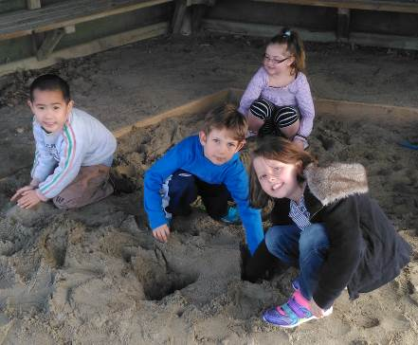

Soccer Results
9th Grade
Winton Lumsden 6 – Waihopai Blue 0
Player of the Day: Harrison Quertier-Kerr

12th Grade
Winton Lumsden 2 – Southend United 1

Netball Results
Results from Saturday 23rd July.
2nd Grade vs Takitimu A Won 27-19 POD Kyla Herrick
4th Grade vs Riverton Lost 4-13 POD Star-ra Ralston
7th Grade vs Riverton Won 17-4 Rachael Miller and Rebekah Kalweit received POD
9th Grade vs Winton A Lost POD Kirsten & Rebecca Armitage.
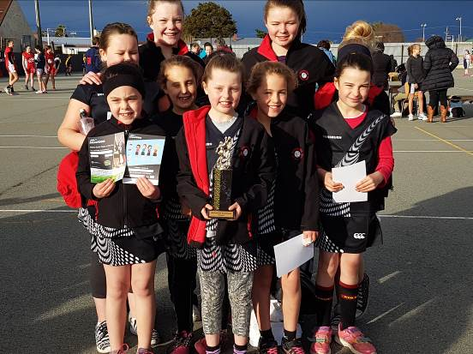

The 9th Grade Team with the Fair Play and Effort Trophy they won from Central.

Rugby Results
The final game of rugby for B Grade was won by Balfour/Lumsden 31 – Riversdale 5
Player of the Year: Josh Lowe
Most improved Player: Trey Stapleforth

Entertainment Books Available Now
2016/2017 books are available at the school office or online. Books cost $60 each and the school receives $12/book profit.

FIREWOOD For Sale: Old man pine - $75 per metre (+ extra for delivery). Fundraiser for Dan Stewart (Mum, Serra, a buddy reader here at school). Dan is raising funds to go to a competition water-ski school. Ph 027 891 3395.





